2023-2024 Health Sciences High & Middle College Sport Packet
Athletic Department and Team Expectations

- Students First, Athletes Second!!!! STUDENT athletes are expected to give 100% effort in ALL classes and internships.

- Athletes are expected to perform to the best of their ability and give a 100% effort at all times on the field or court.

- Athletes will maintain a 2.00 grade point average and have cleared all Incompletes by the start of your season. Students with an Incomplete during the season must develop a grade recovery plan with their coach and the teacher whose class they have an Incomplete in order to practice or compete. If an athlete is carrying an Incomplete after 10 weeks, he/she will be unable to participate in any sport related activity.

- Athletes will attend and be on time to all scheduled practices, unless prearranged with their coach. Participation in events is based upon effort and attendance, not skill.

- Athletes will respect all sports facilities. Clean up after themselves and others.

- All athletes must follow the rules of State CIF, San Diego Section CIF, and the National Federation of State High School Associations. Failure to follow these rules may result in disciplinary action and/or removal from the team.

- All athletes must wear their uniform and all clothing items in accordance with established rules and display a professional, respectful, positive image for HSHMC and the local community. Athletes must return uniform before their end of season banquet.

- DO NO HARM!!!!! Be respectful to all teachers, coaches, athletes and officials. If you have an issue with a coach, student or teacher please see your coach or Ms. Haywood. Please be mindful of your use of language and always use CHOICE WORDS.

I have read and agree to all the above athletic department and team expectations:

Student Athlete Name (Printed): _______________________________________________________
Student Athlete Signature: ______________________________________ Date: ___________
Parent/Guardian Signature: ______________________________________ Date: ___________

PARENT PERMISSION FORM FOR FIELD TRIPS, STUDY-TRAVEL ACTIVITIES
AND TRANSPORTATION FOR CO-CURRICULAR ACTIVITIES

I/We, the parents/guardians of the student named below, understand the nature of the trips being planned for:
School sponsored sports activities and events between June 15, 2023 and June 6, 2024.

We understand that transportation will be by school bus or private transportation and we are in accord with the purposes of and procedures governing the trip. We hereby grant permission for our son/daughter to participate. We understand that adequate and appropriate supervision will be provided. We recognize, however, that unanticipated situations and problems can arise on any trip, school-sponsored or otherwise, which situations or problems are not reasonably within the control of the supervising teacher(s) or staff (including volunteers). We further agree to release and hold harmless the Health Sciences Board of Education, their agents, officers, employees, and volunteers, from any and all liability, claims, suits, demands, judgments, costs, interest and expenses (including attorneys’ fees and costs) arising from such activities, including any accident or injury to the student and the costs of medical services.

I/We also understand that I am to pick up or provide transportation for my son/daughter within 30 minutes of arriving at HSHMC from athletic contest or practice. I understand that inappropriate student behavior will be handled by coaches and or administrators in the same manner as all other student behavior and that privilege of riding the bus to sporting events may be suspended or lost pending a restorative meeting with students and or parents. I also understand and acknowledge that my son/daughter must have the prior approval of the coach/Athletic Director if they are not riding the bus to or from an athletic event. The coach or chaperon must personally release the student to the parent or parent designee after the contest. With the coaches’ approval, a student may travel with his/her parent or the parent of a teammate if there is advanced consent provided in writing. Students will not be released to another student for transportation.

In the event of an injury requiring medical attention, I hereby grant permission to the supervising teacher(s) or staff (including volunteers) to attend to my son/daughter. If the injury warrants further medical attention, I expect every effort will be made to contact me to receive my specific authorization before action is taken. If efforts to contact me are unsuccessful, I grant permission for necessary medical treatment to be given. In addition, I hereby give my permission to the supervising teacher(s) or staff (including volunteers) to take my child to the physician, dentist, or to the hospital if an accident or serious illness occurs on the trip and I cannot be located.

In the event that a student must return to Health Sciences High & Middle College independently for reasons of health, accident, failure to conform to rules established by the teacher in charge, etc., I agree to accept full responsibility for the cost of medical care, transportation and other incidental expenses. This permission slip also serves as a contract that the student and parent(s) understand and agree to the guidelines from each teacher as to making up missed assignments.
Student Name (Please Print): ___________________________________________________________________
Parent/Guardian Signature: __________________________________________ Date: ________________
Home Phone: _________________ Work Phone: _______________ Cell Phone: _________________

Please check below IF your child has sensitivity to:

O Bee Sting O Nuts O Dairy O Latex O Other ___________________________

O Asthma O Diabetes O Kidney Injuries O Seizure Disorder O Heart Condition O Other (Specify)

Required medications: ________________________________________________________________________

_____________________________________________________________________________________________

Health Science High & Middle College Release and Disclosure Form

I hereby authorize the release and disclosure of the personal health information of ______________________________ ("Student"), as described below, to _Health Sciences High and Middle College_("School").

The information described below may be released to the School principal or assistant principal, athletic director, coach, athletic trainer, physical education teacher, school nurse or other member of the School's administrative staff as necessary to evaluate the Student's eligibility to participate in school sponsored activities, including but not limited to interscholastic sports programs, physical education classes or other classroom activities. Personal health information of the Student which may be released and disclosed includes records of physical examinations performed to determine the Student's eligibility to participate in school sponsored activities, including but not limited to the Pre-participation Evaluation form or other similar document required by the School prior to determining eligibility of the Student to participate in classroom or other School sponsored activities; records of the evaluation, diagnosis and treatment of injuries which the Student incurred while engaging in school sponsored activities, including but not limited to practice sessions, training and competition; and other records as necessary to determine the Student's physical fitness to participate in school sponsored activities. The personal health information described above may be released or disclosed to the School by the Student's personal physician or physicians; a physician or other health care professional retained by the School to perform physical examinations to determine the Student's eligibility to participate in certain school sponsored activities or to provide treatment to students injured while participating in such activities, whether or not such physicians or other health care professionals are paid for their services or volunteer their time to the School; or any other EMT, hospital, physician or other health care professional who evaluates, diagnoses or treats an injury or other condition incurred by the student while participating in school sponsored activities.

I understand that the School has requested this authorization to release or disclose the personal health information described above to make certain decisions about the Student's health and ability to participate in certain school sponsored and classroom activities, and that the School is a not a health care provider or health plan covered by federal HIPAA privacy regulations, and the information described below may be redisclosed and may not continue to be protected by the federal HIPAA privacy regulations. I also understand that the School is covered under the federal regulations that govern the privacy of educational records, and that the personal health information disclosed under this authorization may be protected by those regulations. I also understand that health care providers and health plans may not condition the provision of treatment or payment on the signing of this authorization; however, the Student's participation in certain school sponsored activities may be conditioned on the signing of this authorization. I understand that I may revoke this authorization in writing at any time, except to the extent that action has been taken by a health care provider in reliance on this authorization, by sending a written revocation to the school principal (or designee) whose name and address appears below.

Name of Principal: Dr. Dominique Smith School Address: 3910 University Ave. Suite 100 San Diego CA 92105

This authorization will expire when the student is no longer enrolled as a student at the school.

NOTE: IF THE STUDENT IS UNDER 18 YEARS OF AGE, THIS AUTHORIZATION MUST BE SIGNED BY A PARENT OR LEGAL GUARDIAN TO BE VALID. IF THE STUDENT IS 18 YEARS OF AGE OR OVER, THE STUDENT MUST SIGN THIS AUTHORIZATION PERSONALLY.

Student’s Signature: ___________________________ Birth date of Student, including year: _________

Name of Student's Parent/Guardian: ____________________________________________________________

If applicable I am the Student's (check one):

__________ Parent __________ Legal Guardian (documentation must be provided)

Signature of Student's Parent/Guardian : ________________________________ Date: _______________

HSHMC ATHLETIC DEPARTMENT
SOCIAL MEDIA POLICIES FOR ATHLETES AND COACHES

- Assume nothing is private, ever. If you are putting your thoughts on the internet, there is no “invasion of privacy.”

- Remember that your audience is vast, and unknowable. You have no idea who will ever see what you write on the internet. Anyone from your best friend on the team, to your head coach, to your biggest rival, to your teachers can see what you post. Keep in mind that what you say can be seen by the world. Your microphone to the world is right at your fingertips. Be wise and Do No Harm.

- It is against California Interscholastic Federation rules to engage and influence any non-HSHMC student for the purpose of enrolling at HSHMC for athletics. Do not use social media for this purpose. Refer anyone asking about our Athletic teams or department to the Athletic Director.

- Do not discuss injuries, either yours or that of any of your teammates.

- Never post pictures from the locker room, weight room, practice or game without the permission of the Athletic Director or Head Coach.

- Complaining about your coaches or teammates will NOT solve anything. Talk to them directly to solve problems to make yourself and your team better. Always feel free to talk to the Athletic Director or other school Administrator regarding any issues with a coach or teammate.

- Do not talk about your opponents in a negative fashion. Stay away from trash talking your past, present or future opponents.

- Your tweets and posts can be permanent. They are a permanent record. You can’t take back what you put out on the internet for everyone to see.

- If you retweet something, you agree with it and promote it. Keep this in mind.

- Play with your ability and your skills, not your mouth and your fingers on the keyboard.

Student’s Signature: _______________________________________________ Date: ____________

Signature of Student's Parent/Guardian: ____________________________ Date: ____________

Student-athletes who violate the HSHMC Athletic Department Social Media Policy may result in disciplinary action – including temporary or permanent suspension from the team – as determined by the Athletic Director and School Administration.

SPORTS INJURY RISK WARNING AND AGREEMENT

By its very nature, competitive athletics can put students in situations in which SERIOUS, CATASTROPHIC and perhaps FATAL accidents could occur. Students and parents/guardians must assess the risks involved in such participation and make their choice to participate in spite of those risks. No amount of instruction, precaution or supervision will totally eliminate all risk of injury. Just as driving an automobile involves choice of risk, participation in athletics is inherently dangerous. The obligation of parents and students in making this choice to participate cannot be overstated.

By granting permission to your son/daughter to participate in athletic competition, a parent/guardian acknowledges that playing or practicing in any sport can be a dangerous activity involving MANY RISKS OF INJURY. Both the athlete and parent must understand that the dangers and risks of playing or practicing include but are not limited to: death,complete or partial paralysis, brain damage, serious injury to virtually all internal organs, bones, joints, ligaments, muscles, tendons and other aspects of the skeletal system and potential impairment to other aspects of the body, general health and well-being.

Because of the dangers of participating in sports, we (parent and player) recognize the importance of following coaches’ instructions regarding playing techniques, training, equipment and other team rules, etc. both in competition and practice and agree to obey such instructions.

If any of the foregoing is not completely understood and you have questions, please contact your school athletic director or school administrator for further information.

I have read and understand the information above and give my son/daughter permission to participate.

Parent Signature: __________________________________ Date: __________________

I have read and understand the information above and I want to participate.

Student Signature: __________________________________ Date: __________________

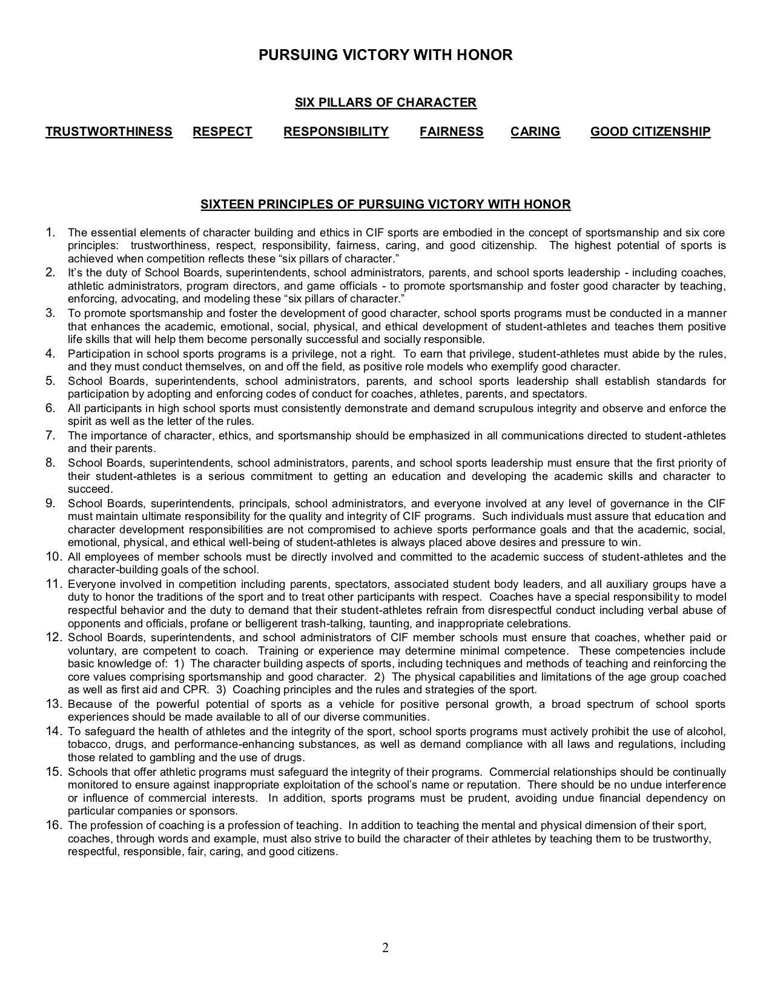

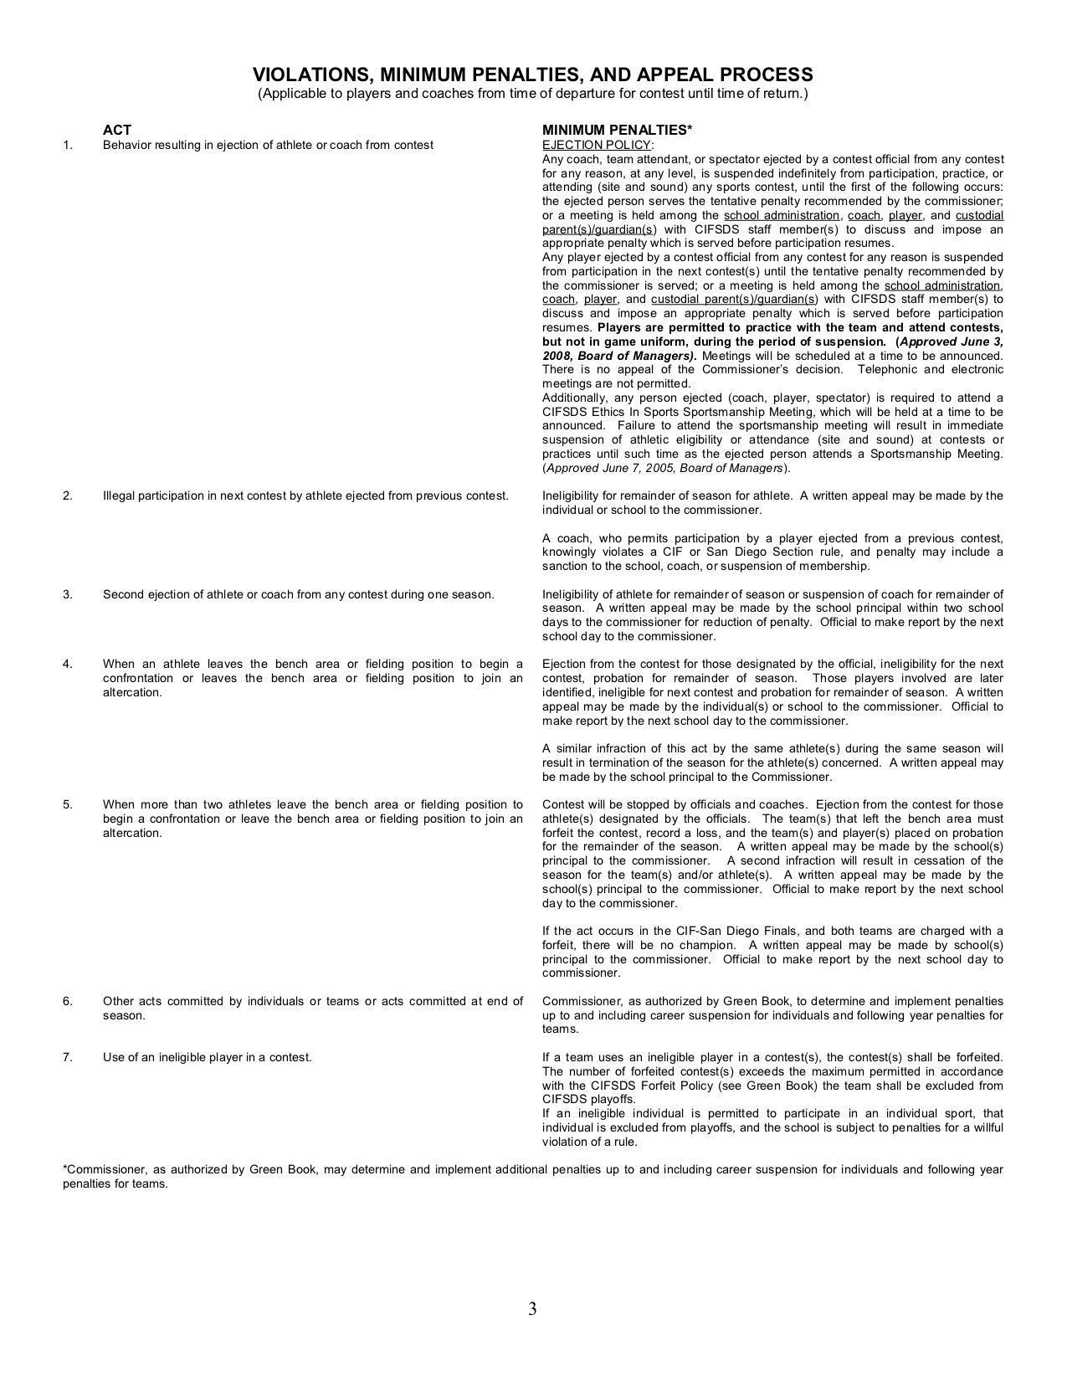

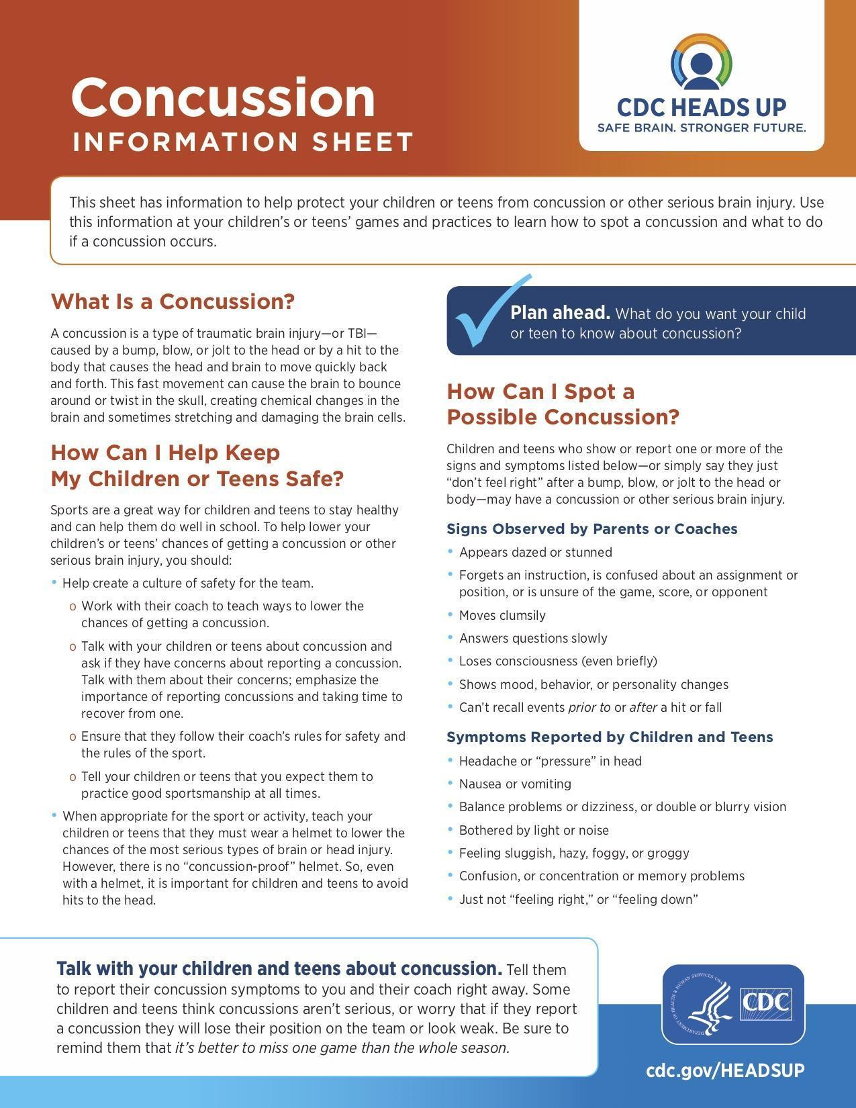
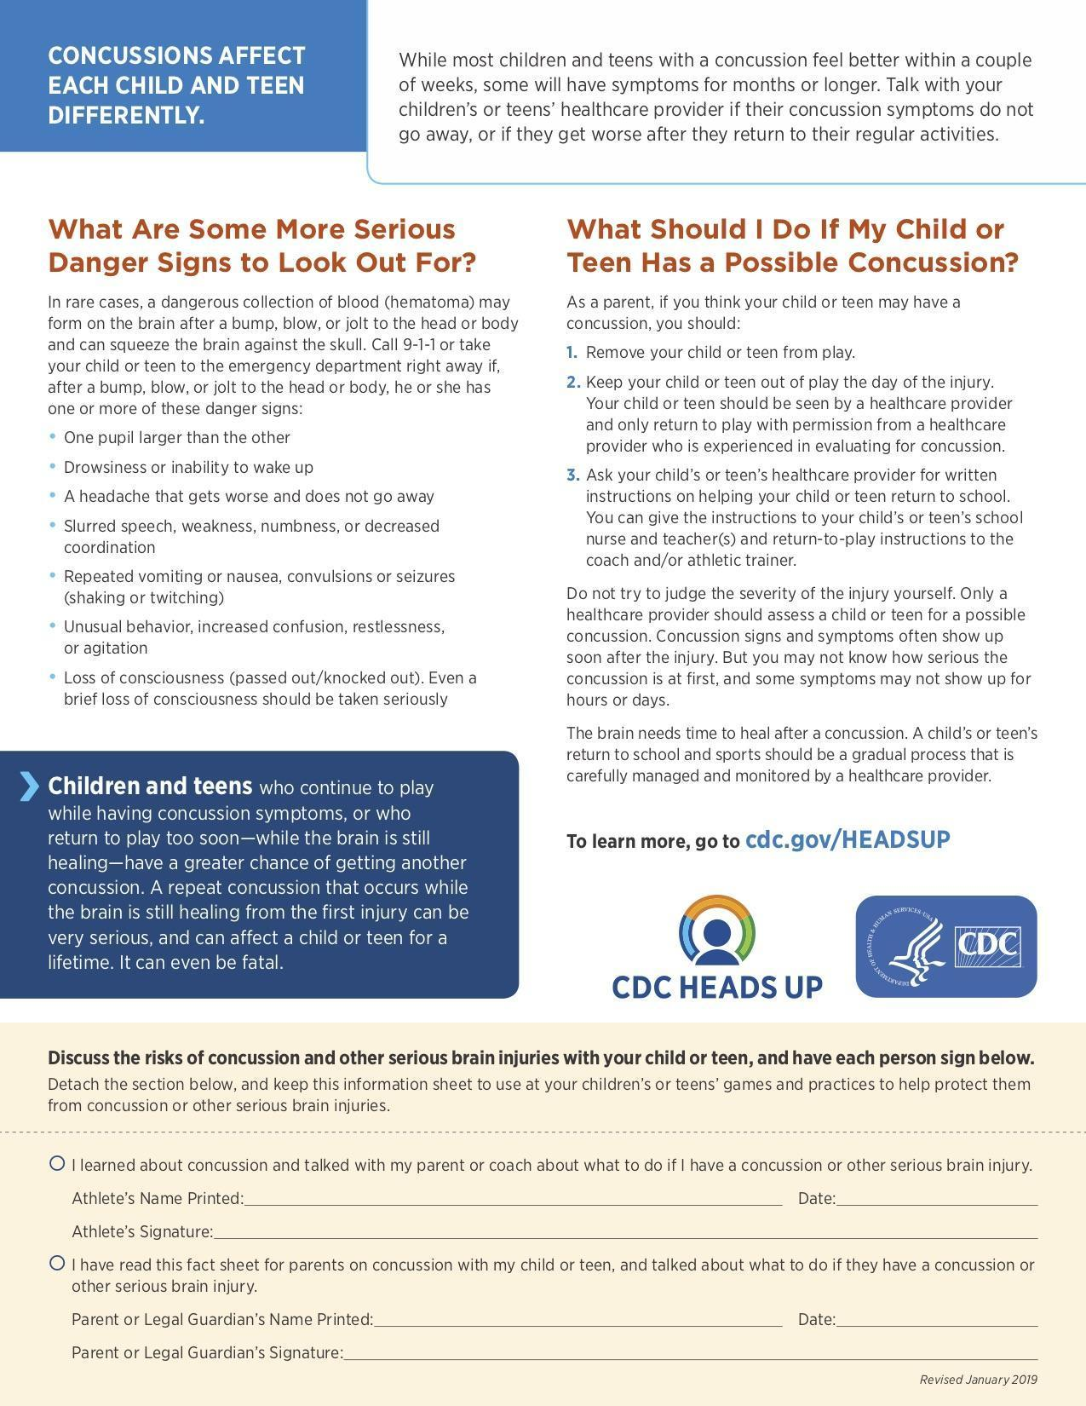

HEALTH SCIENCES HIGH & MIDDLE COLLEGE CONCUSSION CONTRACT

What can happen if my child keeps on playing with a concussion or returns to soon?

Athletes with the signs and symptoms of concussion should be removed from play immediately. Continuing to play with the signs and symptoms of a concussion leaves the young athlete especially vulnerable to greater injury. There is an increased risk of significant damage from a concussion for a period of time after that concussion occurs, particularly if the athlete suffers another concussion before completely recovering from the first one. This can lead to prolonged recovery, or even to severe brain swelling (second impact syndrome) with devastating and even fatal consequences. I

If you think your child has suffered a concussion

Any athlete even suspected of suffering a concussion should be removed from the game or practice immediately. No athlete may return to activity after an apparent head injury or concussion, regardless of how mild it seems or how quickly symptoms clear, without medical clearance. Close observation of the athlete should continue for several hours. The new CIF Bylaw 313 now requires implementation of long and well-established return to play concussion guidelines that have been recommended for several years:

“A student-athlete who is suspected of sustaining a concussion or head injury in a practice or game shall be removed from competition at that time and for the remainder of the day.”
AND
“A student-athlete who has been removed may not return to play until the athlete is evaluated by a licensed healthcare provider trained in the evaluation and management of concussion and received written clearance to return to play from that health care provider.”

You should also inform your child’s coach if you think that your child may have a concussion. Remember it is better to miss one game than miss the whole season. And when in doubt, the athlete sits out.

For current and up-to-date information on concussions you can go to:
https://www.cdc.gov/headsup/highschoolsports/index.html

Student-Athlete Name (Printed): _______________________________________________________ Student-Athlete Signature: ________________________________________ Date: ____________
Parent or Legal Guardian (Printed): _____________________________________________________ Parent or Legal Guardian Signature: _______________________________ Date: ____________

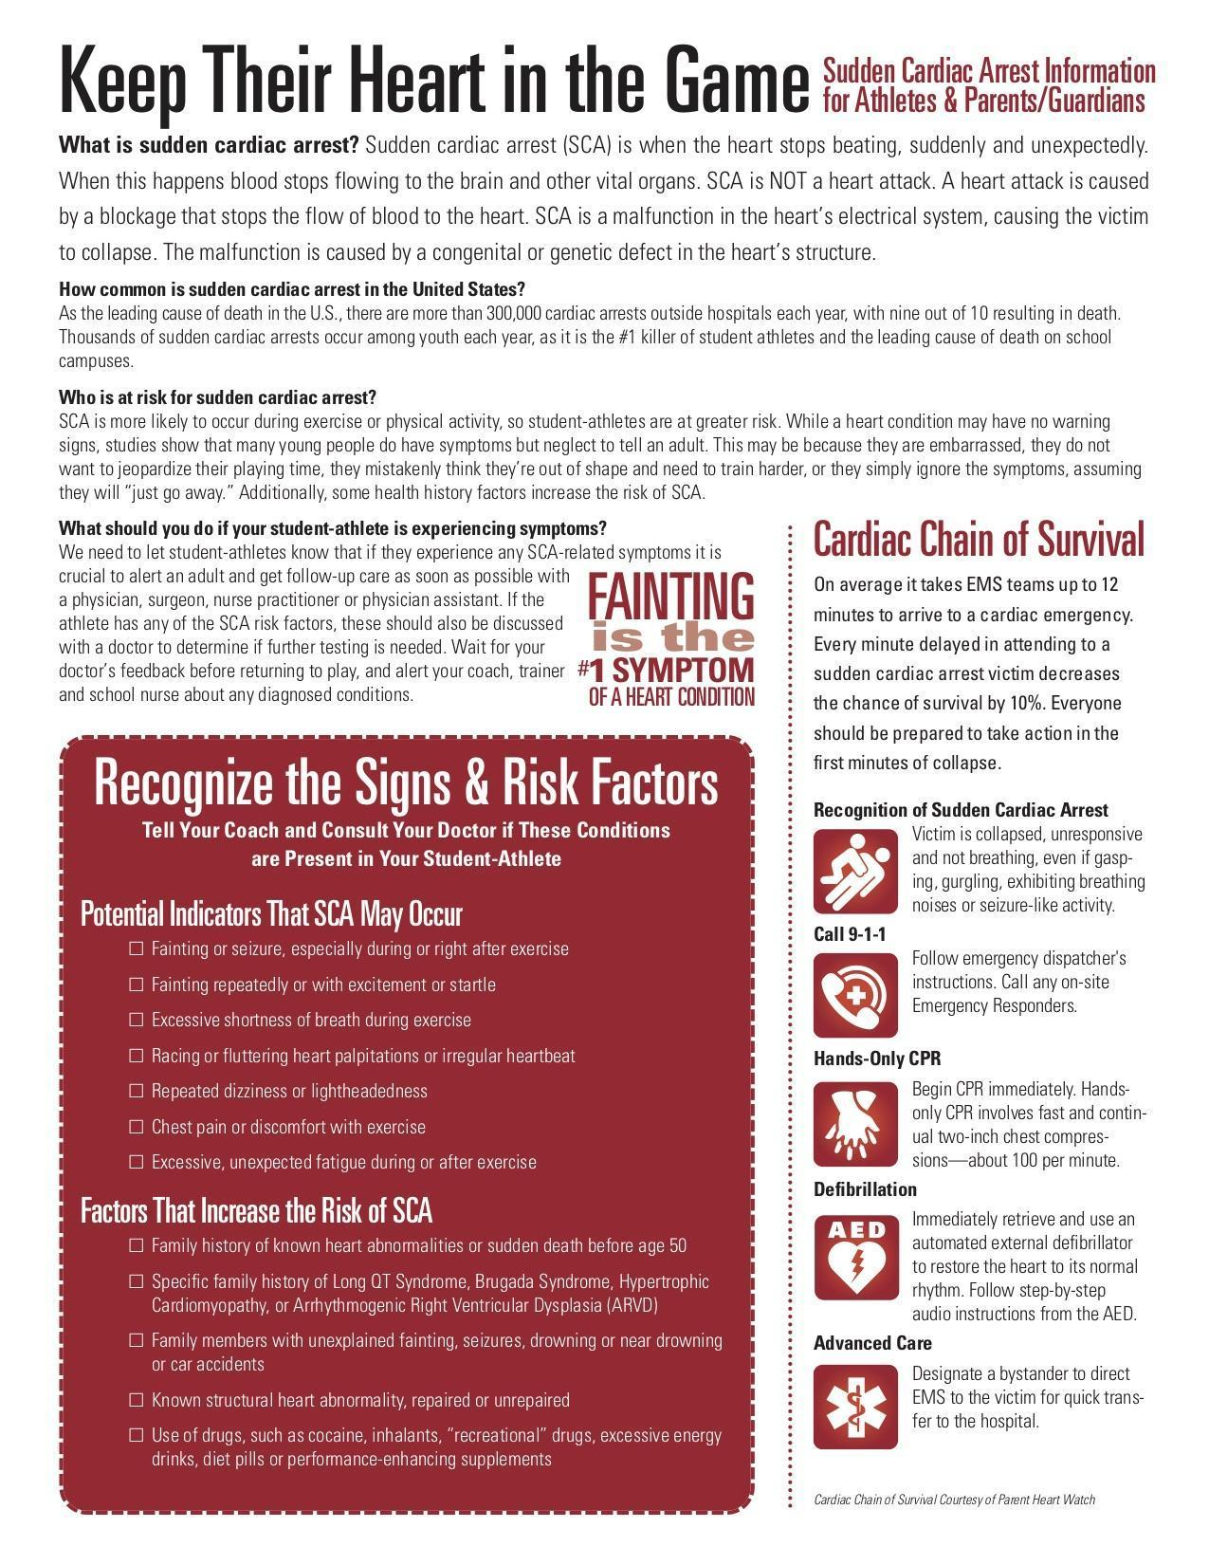
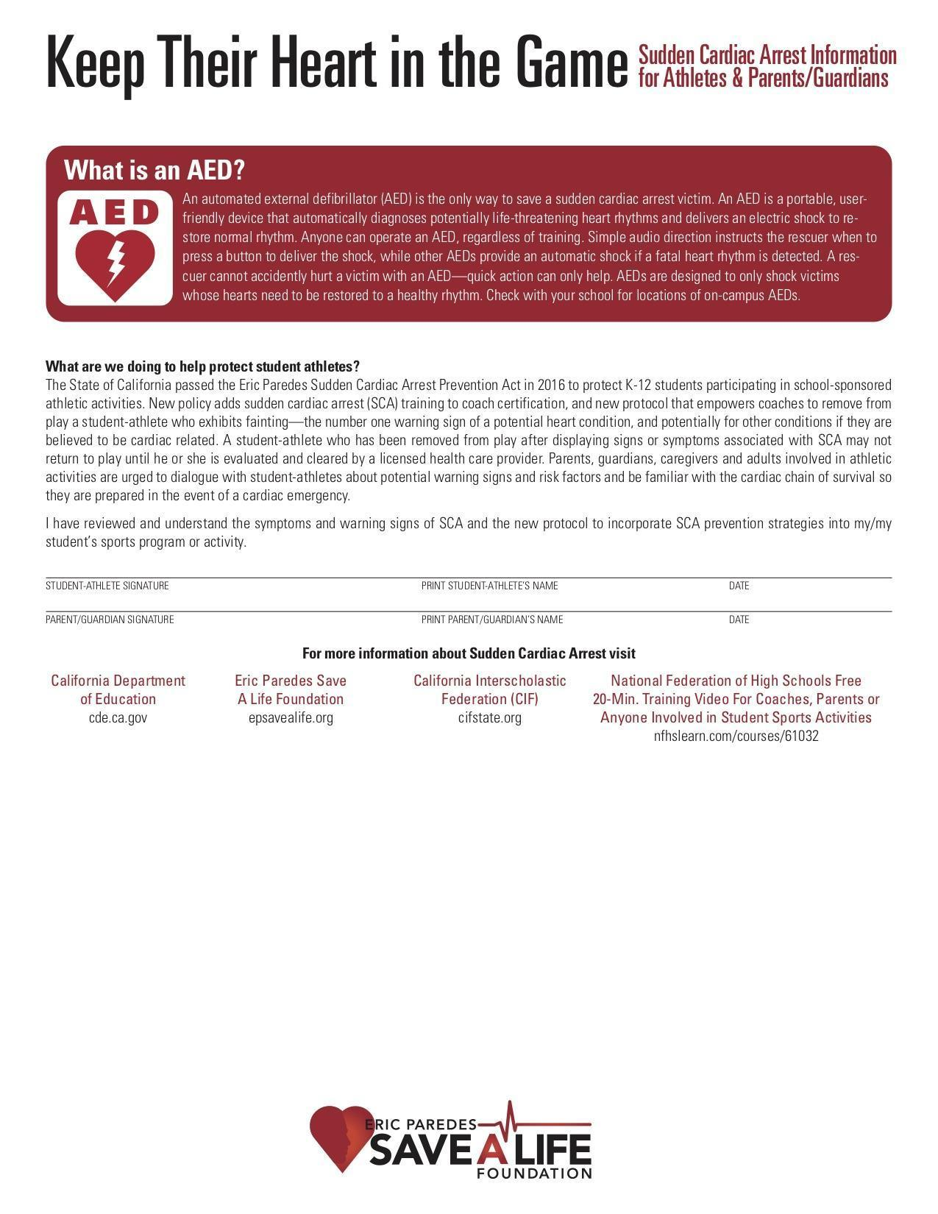

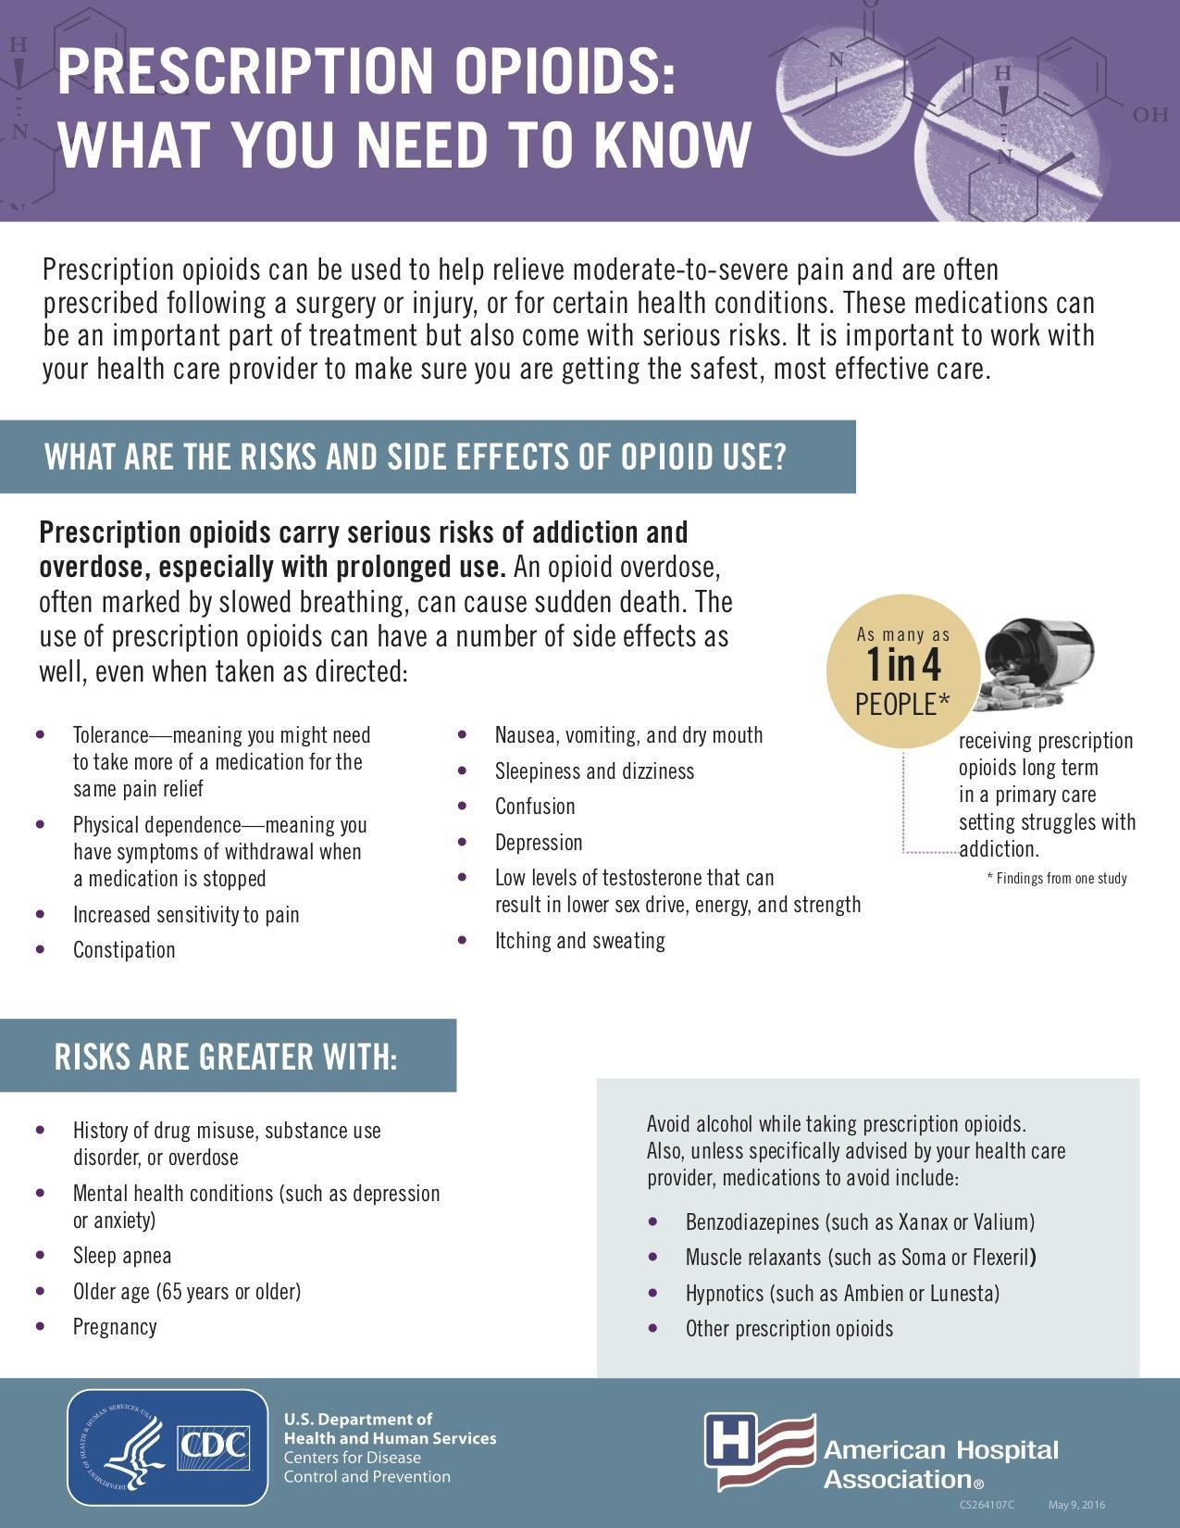
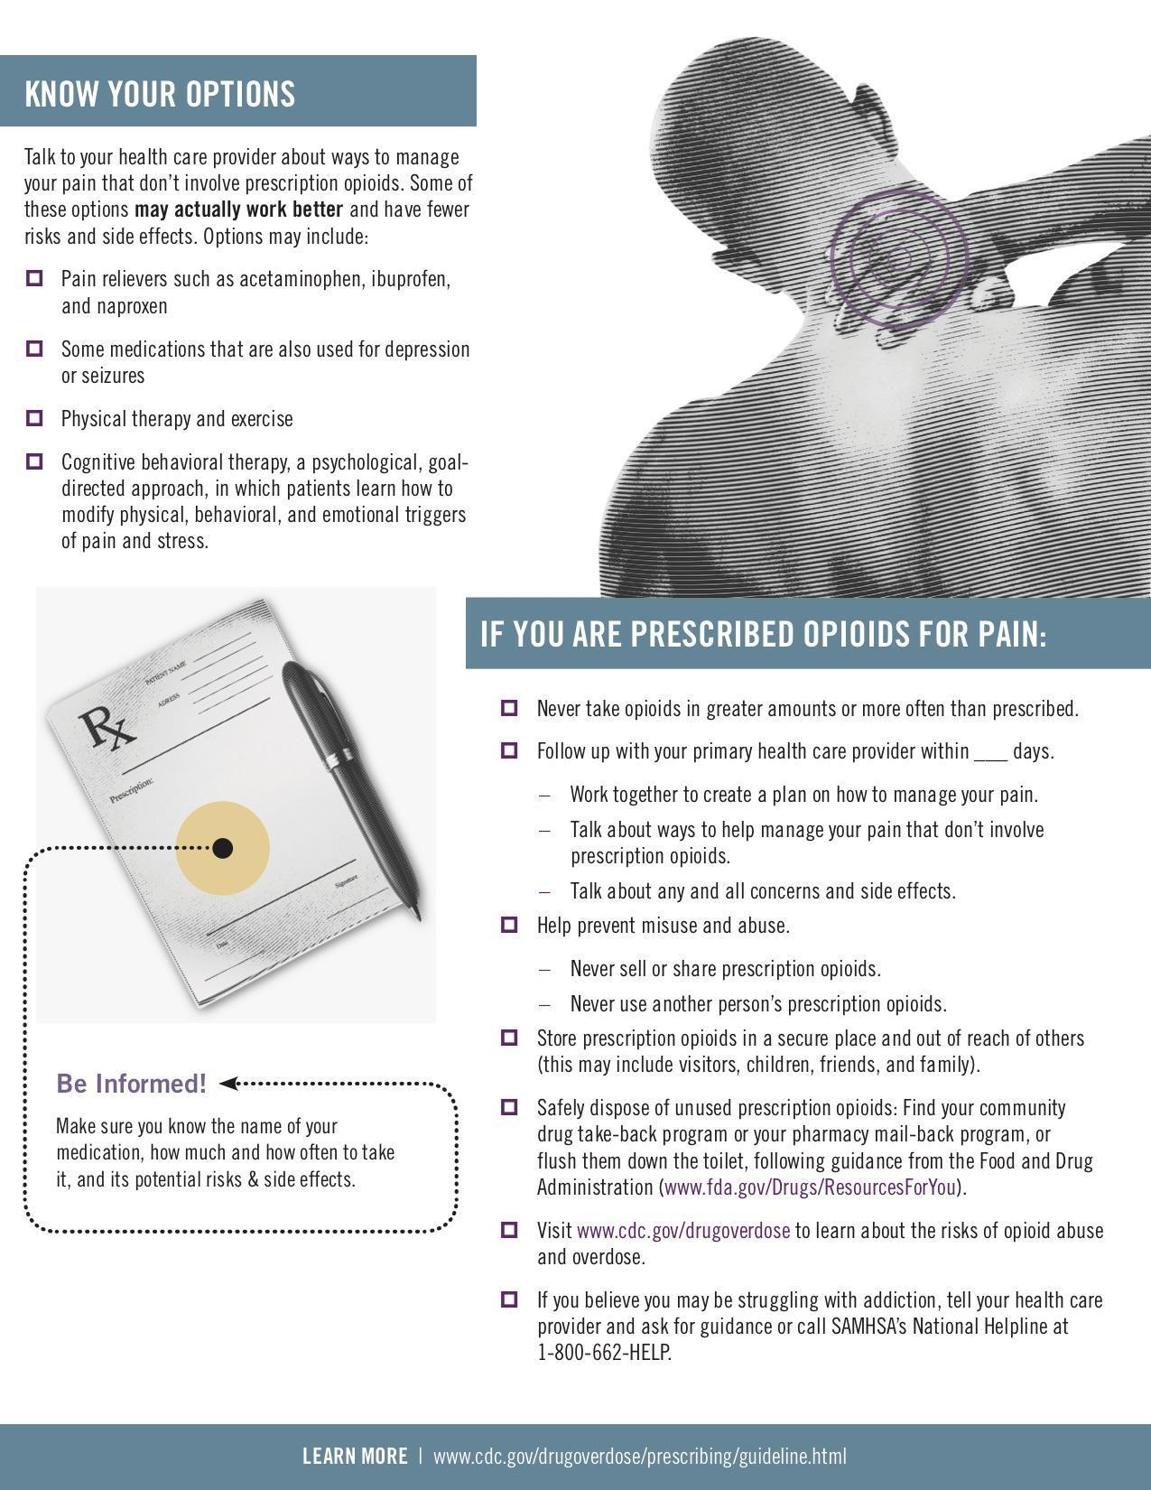
CALIFORNIA INTERSCHOLASTIC FEDERATION
MANDATORY STEROID POLICY

“As a condition of membership into the CIF, all member schools shall adopt policies prohibiting the use and abuse of androgenic/anabolic steroids. All member schools shall have participating student athletes and their parents, legal guardian/caregiver agree that the athlete will not use steroids without the written prescription of a fully-licensed physician (as recognized by the AMA) to treat a medical condition.” (CIF Bylaw 503.I)

SCHOOL: Health Sciences High & Middle College

PRINT NAME OF STUDENT ATHLETE: _____________________________________
GRADE: _____________

By signing below, both the participating student-athlete and the parents, legal guardian/caregiver hereby agree that the student-athlete named herein, shall not use androgenic/anabolic steroids without the written prescription of a fully-licensed physician (as recognized by the AMA) to treat a medical condition. We also recognize that under CIF Bylaw 202, there could be penalties for false or fraudulent information. We also understand that the school’s policy regarding the use of illegal drugs will be enforced for any violations of these rules.

__________________________________________ _______________
Signature of Student-Athlete named above Date

______________________________________________________ ____________________
Print or type name of Parent/Guardian/Caregiver signing below Relationship to student

__________________________________________ _______________
Signature of Parent/Guardian/Caregiver Date

HEALTH SCIENCES HIGH SCHOOL ATHLETIC CLEARANCE CARD

Student Name: ______________________________________________________________________
Grade: ________ Sport(s): _____________________________________
Address: ____________________________________________________________________________
City: ___________________________ ZIP: ____________ Phone: ___________________________
Parent/Guardian Name: _______________________________________________________________
Parent/Guardian Work/Cell Phone: _____________________________________________________

Emergency Contact: ___________________________ Work/Cell Phone: _____________________
Doctor’s Name: ________________________________ Phone: ______________________________
Hospital Choice: _____________________________________________________________________
Medicine Allergies (Please list): ________________________________________________________
List any medications currently taking: ___________________________________________________
_____________________________________________________________________________________

In case of an emergency and if parent/guardian and above medical doctor cannot be reached, permission is given to school authorities to seek emergency medical treatment at a hospital or medical facility.

Parent/Legal Guardian Signature: _______________________ Date: _________________
___________________________________________________________________________________

INSURANCE: I hereby declare that my student (named above), has medical insurance administered by ___________________________ Insurance Co., Policy # (required) _________________________, which will provide coverage for medical and hospital expenses resulting from accidental bodily injury while practicing for or participating in interscholastic athletic events OR subscribes to the required insurance coverage specified through the insurance carrier approved by and made available through Health Sciences High & Middle College.

I ACCEPT FULL RESPONSIBILITY TO NOTIFY THE SCHOOL IMMEDIATELY OF ANY CHANGE OR LAPSE IN THE ABOVE POLICIES.

Parent/Legal Guardian Signature: ___________________________ Date: __________________

TRANSPORTATION WAIVER AGREEMENT FROM HSHMC TO HOME

Upon returning to Health Sciences High & Middle College (HSHMC) from away athletic competitions, athlete pickup by parent/guardian from campus is always preferred whenever feasible. However, it is recognized that, in some cases, it may be in the best interest of the student to be driven home from HSHMC by the parent/guardian of another student on the team, drive himself/herself, walk or arrange for alternative transportation home. In regards to the below three cases, please check the box(es) you approve for your son/daughter:

🔲 Parent/guardian permission for student to walk home

I give permission for my son/daughter to walk home from HSHMC after athletic competitions or practices during their season of sport. In consideration of my son’s/daughter’s participation in the athletics program at HSHMC, I agree to release and hold harmless from legal liability and agree not to sue HSHMC, its employees, agents, representatives, and volunteers for any injuries, physical or psychological, death or personal property damage resulting from my son/daughter walking home after athletic competitions or practices.

🔲 Parent/guardian permission for student to travel with other parents

Transportation home from HSHMC after athletic competitions or practices may be provided by parents/guardians of HSHMC students. These parents will be driving their own private vehicles. HSHMC assumes no responsibility for the driving performance of these parents. The parent driver is responsible for all automobile insurance coverage in case of accident while driving students’ home from HSHMC. Students will be picked up from HSHMC and driven home. In consideration of my son’s/daughter’s participation in the athletics program at HSHMC, I agree to release and hold harmless from legal liability and agree not to sue HSHMC, its employees, agents, representatives, and volunteers for any injuries, physical or psychological, death or personal property damage resulting from my son/daughter walking home after athletic competitions or practices.

🔲 Parent/guardian permission for student to leave campus independently

I give my son/daughter permission to independently go home from HSHMC after athletic competitions or practices. In consideration of my son’s/daughter’s participation in the athletics program at HSHMC, I agree to release and hold harmless from legal liability and agree not to sue HSHMC, its employees, agents, representatives, and volunteers for any injuries, physical or psychological, death or personal property damage resulting from my son/daughter walking home after athletic competitions or practices.

---------------------------------------------------------------------------------------------------------------------------------------------------------------------------------------
I hereby agree to indemnify Health Science High & Middle College, its employees, agents, representatives, and volunteers from any and all liability, loss or damage, costs, or judgments against HSHMC asserted as a result of this transportation waiver agreement. I have read this release and waiver of liability and indemnification agreement. I fully understand its terms, understand that I have given up substantial rights by signing it, and have signed it freely and voluntarily. And I intend my signature to be complete and unconditional release of all liability to the greatest extent allowed by law.

Student’s Name: ___________________________________________________ Sport(s): _________________________

Parent/Guardian’s Name: ____________________________________________ Date: ___________________________

Parent/Guardian’ Signature: ___________________________________________ Mobile Phone: ___________________

HSHMC ONSITE WEIGHT ROOM
EXERCISE INJURY RISK WARNING AND AGREEMENT - STUDENT

In consideration of Health Sciences High & Middle College (hereinafter referred to as “school”) permitting students to utilize it’s onsite weight room and equipment, and with the understanding that the undersigned is under no obligation to use these facilities and equipment but does so on his/her own free will, the undersigned agrees to abide by all the rules of the facility and acknowledge as follows:

By its very nature, exercise and strenuous activity can put students in situations in which SERIOUS, CATASTROPHIC and perhaps FATAL accidents could occur. Students and parents/guardians must assess the risks involved in such participation and make their choice to participate in activities of those risks. No amount of instruction, precaution or supervision will totally eliminate all risk of injury. Just as driving an automobile involves choice of risk, participation in exercise and strenuous activity is inherently dangerous. The obligation of parents and students in making this choice to participate cannot be overstated.

Because use of these facilities (onsite weight room) can involve strenuous physical activity, there is an inherent risk of serious injury, illness or even death. Therefore, each person who uses these facilities is urged to obtain a physical examination from a doctor prior to using the exercise equipment or engaging in the physical exercise activities offered by this facility.

By granting permission to your son/daughter to participate, a parent/guardian acknowledges that any exercise or strenuous activity can be a dangerous activity involving MANY RISKS OF INJURY. Both the student and parent must understand that the dangers and risks of participating include but are not limited to: death,complete or partial paralysis, brain damage, serious injury to virtually all internal organs, bones, joints, ligaments, muscles, tendons and other aspects of the skeletal system and potential impairment to other aspects of the body, general health and well-being.

Because of the dangers of participating in exercise and strenuous physical activity, we (parent and student) recognize the importance of following teachers’ and coaches’ instructions regarding weight room techniques, training, equipment and other weight room rules and agree to obey such instructions.

If any of the foregoing is not completely understood and you have questions, please contact your school athletic director or school administrator for further information.

I have read and understood the information above and gave my son/daughter permission to participate.

Parent Signature: __________________________________ Date: __________________

I have read and understand the information above and I want to participate.

Student Signature: __________________________________ Date: __________________

